Research plan:

* Time period: 2000 – 2019, average effect over 10-year period only

1. Estimate Primary
$$TFPG=\hat{Y}-s_{K}\hat{K}-s_{L}\hat{L}$$

2. $\hat{Y}$: GDP, GDP deflator
3. $s_{K}, s_{L}$: $s_{K}+s_{L}=1$-> $s_{K}=1-s_{L}$

* share of labor will use Korea’s Labor institute’s LS2 whose number is matches original estimates

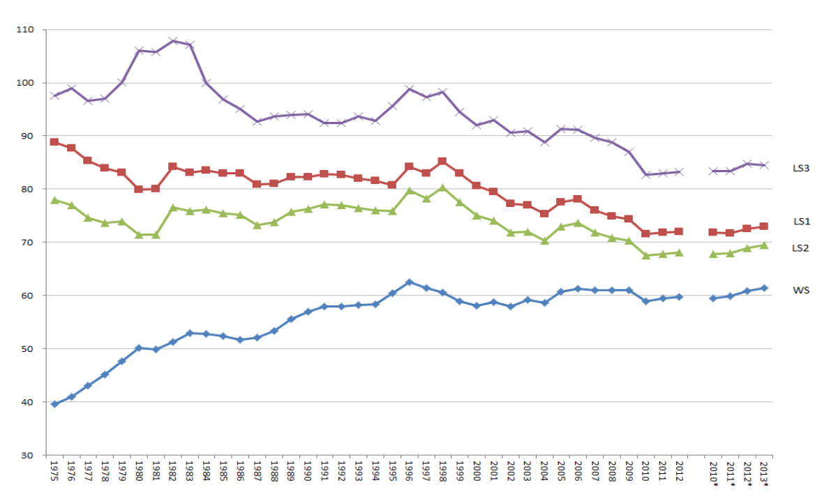

* share of labor and share are assumed to be constant in the first stage. (simple average)

1. $\hat{K}$: GFCF percentage change in real term.
2. $\hat{L}$: change in employed population
3. Estimate Secondary
$$TFPG=s_{K}\hat{r}+s_{L}\hat{w}$$

4. $\hat{r}$: most difficult to estimate. For actual number, they are available on CEIC by types of capital. But some cleaning is required
5. $\hat{w}$: uses yearly figure on occupation weight published on Statistics Korea. <https://kostat.go.kr/portal/eng/pressReleases/5/1/index.board>

And ministry of employment and labor

[https://www.moel.go.kr/english/pas/pasMOEL.jsp#](https://www.moel.go.kr/english/pas/pasMOEL.jsp)

(I am not sure how to adjust for male and female, nice if we could discuss on Fri)

1. $s_{K}, s_{L}$ will be the same as primary